ARMY PUBLIC SCHOOL HISAR
Topic: ‘Recreation’
Subject: EVS
Worksheet No: 2
Class: III
Number-7
Q.1. Look at the photos of the famous Indian personalities and match their names associated with their profession.
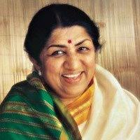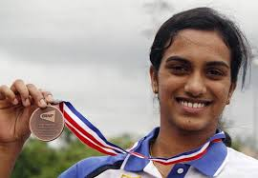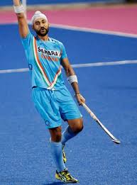
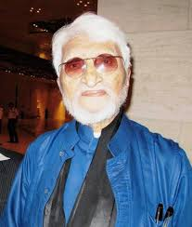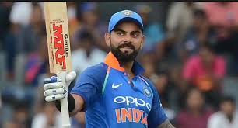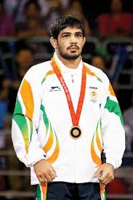
- P.V. Sindhu a. Hockey
- Sushil kumar b. Singer
- Virat kohli c. Painter
- Lata Mangeshkar d. Cricket
- Sanjeev Kapoor e. Wrestler
- M.F. Hussain g. Chef
- Sandeep Singh h. Badminton
Q.2. Write five lines on your favorite hobby.
1. _______________________________________________________________________________________.
2. _______________________________________________________________________________________.
3. _______________________________________________________________________________________.
4. _______________________________________________________________________________________.
5. _______________________________________________________________________________________.

