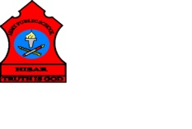
ARMY PUBLIC SCHOOL HISAR
Topic: CH-7, THE FOOD WE EAT
Subject: EVS
Worksheet No: 2
Class: III

- Circle the odd one out:
- Banana, sugarcane, nuts, potato
- Spinach, lettuce, gram, cabbage
- Milk, butter, apple, cheese
- Juice, lassi, almonds, lemonade
B. Draw and colour your favorite food including fruits and vegetables.

