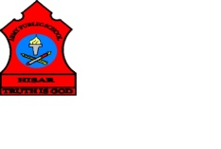
ARMY PUBLIC SCHOOL HISAR
Topic: CH-7, THE FOOD WE EAT
Subject: EVS
Worksheet No: 1
Class: III
Number-12
- Tick the correct answer:
- When we are asleep, some parts of our body are
- Sleeping b. working c. resting
- The more physical work we do, the more energy is required by our body. The following food gives us energy-
- Rice, chapattis b. eggs and cheese c. green leafy vegetables
- One of the food items that contains about 96% of water is
- Mango b. cucumber c. eggs
- Name the following:
- Two energy giving foods _________________, _________________.
- Two body building foods_________________, _________________.
- Two protective foods____________________, _________________.
- Draw different types of food given below:
Energy giving food Body building food

Protective food

