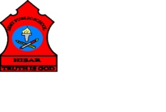
ARMY PUBLIC SCHOOL HISAR
Topic: CH-8, LOOKING AFTER OUR BODY
Subject: EVS
Worksheet No: 1
Class: III
Number-13
- Tick the correct answer:
- Which one of these colours on the traffic signals you to stop?
- Green b. Red c. Amber
- Why should you not fly kites on the terrace?
- You may get burnt b. you may fall ill c. you may fall off
- Which of these should be used by children only in the presence of an adult?
- Match box b. knife c. all of these
- Which of these will you use on a minor burn?
- Hot water b. cold water c. warm water
- Answer the following questions briefly:
Write two examples for each of the following:
- Sharp objects that can cause injury. ____________, ______________.
- Colours of the traffic light. ______________, ____________________.
- Example of junk food. _________________, _____________________.
- Draw and colour traffic lights.

