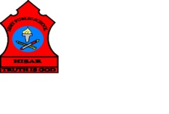
ARMY PUBLIC SCHOOL HISAR
Topic: CH-8, LOOKING AFTER OUR BODY
Subject: EVS
Worksheet No: 2
Class: III
Number-14
- Fill in the blanks:
ZEBRA WAIT SHARP ELECTRICAL

- We should not touch________________ switches with our wet hands.
- We should ____________for our turn while playing on the swings.
- We should cross the road at the ____________ crossing.
- We should not play with ___________objects.
- Draw a first aid box.

li

- Draw some items you keep in first aid box.

